Participant Handout
HP Unconscious Bias

Rev. # or date
HP Restricted

Legal notice
© Copyright 2016 Hewlett-Packard Development Company, L.P.
The information contained herein is subject to change without notice. The only warranties for HP products and services are set forth in the express warranty statements accompanying such products and services. Nothing herein should be construed as constituting an additional warranty. HP shall not be liable for technical or editorial errors or omissions contained herein.
This is an HP copyrighted work that may not be reproduced without the written permission of HP. You may not use these materials to deliver training to any person outside of your organization without the written permission of HP.
Participant Handout
Unconscious bias
May 2016
HP Confidential – For training purposes only

Blind Spots

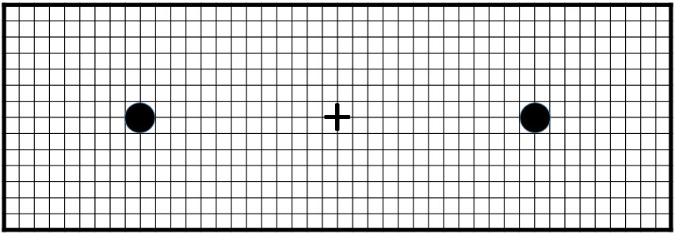

Social perception: warmth and competence

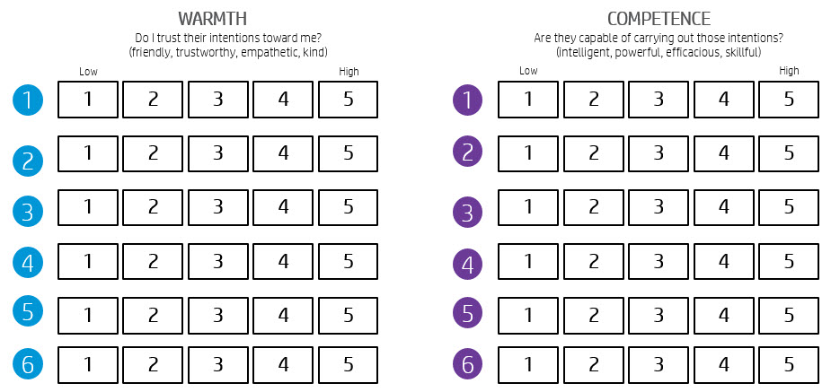

Unconscious Bias - MY COMMITMENT

Ideas:
Actions:

Unconscious Bias  MY COMMITMENT |  |  |  |  | Unconscious Bias  MY COMMITMENT |  |  |  |  | Unconscious Bias  MY COMMITMENT

